**7th Grade**

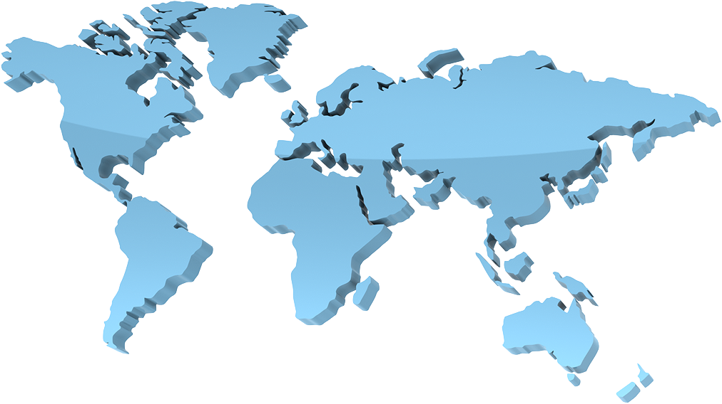

**Social Studies**

**Mr. Feagans**

**COURSE OBJECTIVES:**

**Welcome to 7th grade social studies. Students will learn lifetime skills, listening, reading, following directions, organizing work and materials, taking notes, and HOW TO BE GOOD CITIZENS. This year will be studying the Eastern Hemisphere, which includes the regions and nations of Africa, Asia, and the Southwest Pacific. We will be exploring the people, places and cultures of these regions throughout the year. The 7th grade curriculum also focuses on the Five Themes of Geography. Students will also learn lifetime skills to become successful in our society.**

**We will be following the Indiana State Standards for 7th grade Social Studies.**

**http://dc.doe.in.gov/Standards/AcademicStandards/StandardSearch.aspx**

**GRADING PROCEDURES:**

Grades are based on the completion and evaluation of class assignments, attitude, quizzes, and tests according to the following scale:

**90 - 100% A**SHOULD BE GOAL**

**80 - 89% B**

**70 - 79% C**

**60 - 69% D**

**GRADES ARE BASED ON:**

* **PROJECTS**
* **CURRENT EVENTS**
* **IN-CLASS WORK**
* **TESTS**
* **ORGANIZATION SKILLS AND CLASSROOM SKILLS**

**ACADEMIC HONESTY:**

**ALL work must be done using your OWN hands (exceptions may be made for an extended illness). Quizzes, tests, and product work are to be done with NO outside help. Any individual who has submitted someone else's work as your own work will receive an F for that assignment.**

**MATERIALS REQUIRED TO BE SUCCESSFUL IN THIS CLASS:**

**Students will be expected to bring the following materials to class EVERYDAY. Failure to bring required supplies on a frequent basis will result in a discipline referral.**

**1. Textbook**

**2. Folder with pockets**

1. **Pen or pencil**
2. **Class Folder**
3. **Agenda**
4. **Red pens for grading**

**In order to be successful in the class, these GUIDELINES WILL be followed. It is also recommended that common courtesy and respect be used at all times.**

**1. AN INDIVIDUAL WILL NOT BE ALLOWED TO DAMAGE ANOTHER STUDENT'S OPPORTUNITY TO LEARN IN THIS CLASSROOM.**

**2. All students are expected to give their best possible effort at all times.**

**3. Students will be in their seats with their text, folder, paper, pen, and pencil ready to begin class before the bell sounds every day. If you are not ready you will be marked tardy.**

1. **Students are expected to read and follow the directions FIRST and ask questions if anything is unclear.**
2. **DO THE RIGHT THING!**

**ADDITIONAL HELP: Mr. Feagans will be available for extra help upon discussion.**

**TO BE SUCCESSFUL IN MR. FEAGANS' CLASSROOM:**

**1. GIVE YOUR BEST EFFORT WITH HARD WORK AND A LOT OF PRACTICE.**

**2. COME TO CLASS EVERYDAY.**

**3. LISTEN AND FOLLOW DIRECTIONS.**

**4. ASK QUESTIONS--THERE IS NEVER A STUPID QUESTION!!!!!!!**

**I HAVE READ THE CLASS POLICY AND UNDERSTAND MY EXPECTATIONS!**

**===========================**

**AS A PARENT/GUARDIAN, I HAVE READ THE CLASS POLICY AND BACK MY CHILD IN THIS CLASS.**

**===========================**

**THANK YOU**

**MR. FEAGANS**

GRADE 7 Standards

http://dc.doe.in.gov/Standards/AcademicStandards/StandardSearch.aspx

Peoples, Places and Cultures in Africa, Asia and the Southwest Pacific

Students in Grade 7 study the regions and nations of Africa, Asia and the Southwest Pacific, including historical, geographical, economic, political and cultural relationships. This study includes the following regions: Africa, Southwest and Central Asia, South Asia, Southeast Asia, East Asia, and the Southwest Pacific (Australia, New Zealand and Oceania).

The Indiana’s K – 8 academic standards for social studies are organized around four content areas. The content area standards and the types of learning experiences they provide to students in Grade 7 are described below. On the pages that follow, age-appropriate concepts are listed for each standard. Skills for thinking, inquiry and participation in a democratic society, including the examination of Individuals, Society and Culture, are integrated throughout. Specific terms are defined and examples are provided when necessary.

Standard 1 — History

Students will examine the major movements, events and figures that contributed to the development of Africa, Asia and the Southwest Pacific from ancient civilizations to modern times by examining religious institutions, trade and cultural interactions, political institutions, and technological developments.

Standard 2 — Civics and Government

Students will trace the development of different forms of government in different historical eras and compare various contemporary political structures in Africa, Asia, and the Southwest Pacific in terms of power, approach to human rights, and roles of citizens.

Standard 3 — Geography

Students will explain how atmospheric and oceanic systems affect the seasons and climate. They will understand and use technology and grid systems to identify and locate places geographically. They will identify and categorize the major geographic characteristics and regions of Africa, Asia and the Southwest Pacific. They will also name and locate major physical features, countries and major cities and will use geographic skills and technology to examine geographic relationships within and between these regions and the rest of the world.

Standard 4 — Economics

Students will examine the influence of physical and cultural factors upon the economic systems found in countries of Africa, Asia and the Southwest Pacific.

Standard 1